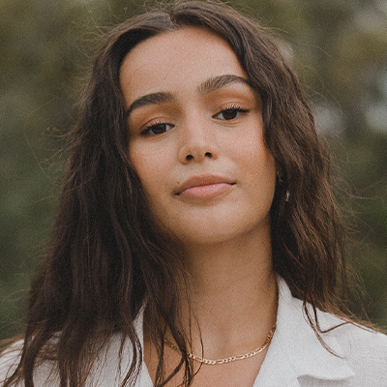
NAME SURNAME
JOB TITLE
Creative and detail-oriented Interior Decorator with a passion for transforming spaces into aesthetically pleasing and functional environments. Proven ability to collaborate with clients to understand their vision and deliver personalized design solutions. Strong expertise in utilizing a wide range of design elements to enhance interiors and create unique atmospheres.




BA Interior Design
NYU – City – State | 20XX-20XX

MA Interior Design
NYU - City – State | 20XX-20XX

EDUCATION
LANGUAGES
Linkedin.url/profile

+1 22 22 22 22
- English
- French
- Italian
Interior Decorator
ABC Interiors - City – State | 20XX-20XX

- Led the redesign of a commercial office space, optimizing layout and functionality to improve workflow and employee satisfaction.
- Established and maintained strong relationships with suppliers.
Design Innovations - City – State | 20XX-20XX

Junior Designer
- Assisted in the development of design concepts for residential and commercial projects, contributing innovative ideas and solutions.
- Collaborated with senior designers to create mood boards, 3D renderings, and detailed project documentation.
PROFESSIONAL EXPERIENCE
Senior Interior Designer
XYZ Design Studio - City – State | 20XX-20XX

- Spearheaded the design and implementation of a high-profile residential project, resulting in a 20% increase in client satisfaction.
- Collaborated with a cross-functional team to ensure seamless execution of design concepts. resources effectively.
NY, USA
- Exhibitions
- Volunteering
- Traveling
- AutoCad
- SketchUp
- Adobe Creative Suite
- Space Planning
- Color Theory
- Furniture Selection
- Lighting Design
CONTACT
SOFTWARE
SKILLS
INTERESTS

©AZURIUS - My-resume-templates.com



Dear Job Seeker,

If you're having difficulty composing your resume, here are some free resources available that can assist you in creating a strong resume that highlights your suitability for the position to potential employers:
- How to Make a Good Resume
- Skills to Put on a Resume
- Resume Objective Examples

Also, discover other free downloadable and ready-to-fill CV templates in Word format:
- Basic Resume Templates
- Modern Resume Templates
- Creative Resume Templates
- Professional Resume Templates
- Europass CV

Best regards,
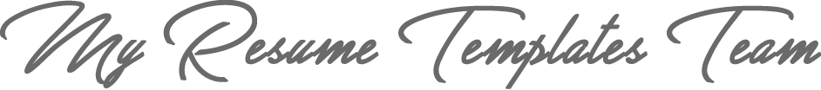

www.my-resume-templates.com

COPYRIGHT - PLEASE READ THIS MESSAGE
©These examples of free resume templates are the property of Azurius S.L. You may
download and modify them without any problem if they are for personal use.
Do not forget to remove this copyright notice before modifying and printing your CV.
You cannot resell these examples or their derivatives. You cannot make them available on other websites without our consent. For any related questions, please write to us at contact@my-resume-templates.com
Discover more resume templates at www.my-resume-templates.com

