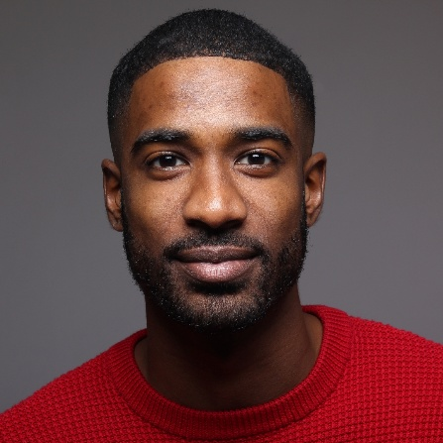




WORK EXPERIENCE
Mitchell & Associates Law Firm
20xx - Present | Washington, D.C.
SENIOR LABOR ATTORNEY
- Represented clients in labor contract negotiations, ensuring compliance with state and federal labor laws.
- Advised companies on labor law compliance, reducing litigation risks and strengthening corporate policies.
- Litigated employment disputes, achieving an 85% success rate.
- Assisted in drafting judicial opinions on labor and employment cases.
- Conducted research on workplace discrimination and employment contract enforcement.
- Managed case documentation and supported courtroom proceedings.
United States District Court for the Southern District of New York
20xx - 20xx | New York, NY
JUNIOR ATTORNEY
LEGAL ASSOCIATE
20xx - 20xx | New York, NY
Smith & Partners LLP
- Conducted legal research on labor law and regulatory frameworks.
- Drafted legal documents, including pleadings, responses, and motions under senior attorneys' supervision.
- Assisted in trial preparation, including evidence gathering and witness coordination.
EDUCATION
Master of Laws (LL.M.) in Labor & Employment Law
Juris Doctor (J.D.)
20xx - 20xx | Columbia Law School, New York, NY
20xx - 20xx | Georgetown University Law Center, Washington, D.C.
CERTIFICATIONS & COURSES
- Certified in Corporate & Employment Law Compliance
- Intellectual Property & Copyright Law Course
- Alternative Dispute Resolution Certification
Experienced labor and employment attorney with over five years of expertise in collective bargaining negotiations, labor dispute resolution, and regulatory compliance. Proven ability to represent clients in judicial and administrative proceedings. Strong analytical and communication skills, with a focus on mitigating legal risks for corporations.

Collective bargaining & contract negotiation
Employment litigation & compliance
Legal research & case analysis
Corporate policy advisory
Risk mitigation & dispute resolution
Courtroom representation
SKILLS
LANGUAGES
English: Native
Spanish: Fluent
German: Beginner
©AZURIUS – Modelos-de-curriculum.com
PROFESSIONAL SUMMARY
MITCHELL
CONTACT
Washington, D.C.
james.mitchell@mail.com
c
+1 (202) 555-7890
linkedin.com/in/j.mitchell
JAMES


Dear Job Seeker,

If you're having difficulty composing your resume, here are some free resources available that can assist you in creating a strong resume that highlights your suitability for the position to potential employers:
- How to Make a Good Resume
- Skills to Put on a Resume
- Resume Objective Examples

Also, discover other free downloadable and ready-to-fill CV templates in Word format:
- Basic Resume Templates
- Modern Resume Templates
- Creative Resume Templates
- Professional Resume Templates
- Europass CV

Best regards,


www.my-resume-templates.com

COPYRIGHT - PLEASE READ THIS MESSAGE
©These examples of free resume templates are the property of Azurius S.L. You may
download and modify them without any problem if they are for personal use.
Do not forget to remove this copyright notice before modifying and printing your CV.
You cannot resell these examples or their derivatives. You cannot make them available on other websites without our consent. For any related questions, please write to us at contact@my-resume-templates.com
Discover more resume templates at www.my-resume-templates.com

